Scope of Work.

Build a web site using Django framework using the Template provided in [Figma](https://www.figma.com/design/DuU5AmelCMGrGIL3X6UVxR/Copy%3A--GoldstreetConsulting.com-Website-Project?node-id=0-1&node-type=canvas&t=j86LV3R5CcIKTS09-0). Use the PostgreSQL database from the [Live site](https://anangtawiah.com/). This phase of the project is to focus on two sections on the home page

1. Services

* Content Management:
  + Services Pages functionality:
    - Build an admin page to ADD a new service and the details of the services.
    - Build an admin page to DELETE a new service and the details of the services.
    - Build an admin page to EDIT a new service and the details of the services.
  + Database:
    - Build a necessary table to capture data. Integrate the home page Service sections with the back-end database and pull list of services. Hyper link each service to its own page with the details captured.

1. Publications

Use the current live site blog database back end to

Populate the data for the new publication template (see the attached screen shot). Add any additional fields that are need for the publication layout

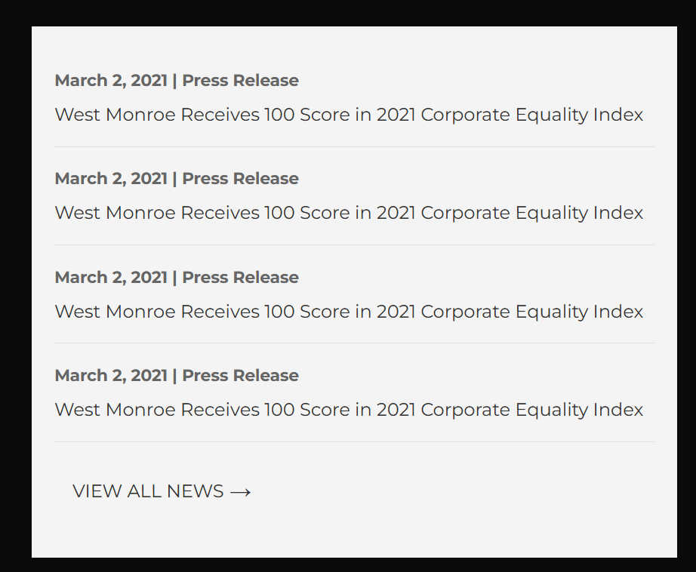

Queries:  
  
1. Date - dateAdded(Blogs Table).

1. Press Release - ?
2. West Monroe Receives 100 Score in 2021 Corporate Equality Index - shortDescription (Blogs Table)

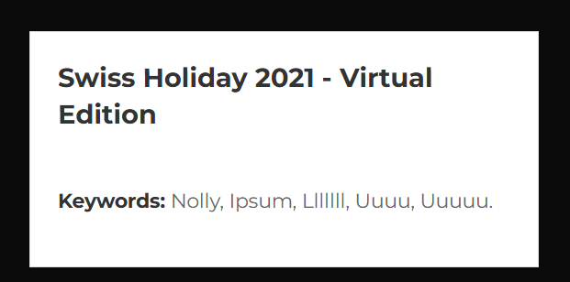

1. Heading - Short Description(Blogs Table)  
   2. Keywords - ?